

quantity surveying

CONSTRUCTION ASSIGNMENT

WHAT YOU DO |  | You will  - Work out the quantities of materials for a single detached garage using the given drawings and a spreadsheet for your calculations  - Work out the main materials costs of constructing the garage  - Submit your costs to your client
EQUIPMENT AND MATERIALS |  | - Drawings of the garage  - Take-off sheets (optional)  - Excel or similar spreadsheet, and Word, plus computer and printer  - Costs of materials and components
QUALIFICATION UNITS |  | VRQ: Level 2 Construction Technology and the Built Environment (C&G 6303) – Unit 007 Site organisation and planning for construction – outcome 4  Edexcel Level 2 BTEC First Diploma in Construction - Unit 4: Construction Processes and Operations – outcome 3

 |  | You work for yourself as a small builder and you have been invited by a potential client to submit your costs for building a detached garage in the grounds of a large house. The plans have been drawn up by an architectural technologist. You have been given these plans to calculate your costs.
TASK 1 |  | Taking off the dimensions  - Take off (measure) each part of the building in turn and work out the area or volume.  - Refer to Information Sheet No. 3 to help you understand the measurements or sizes required.
TASK 2 |  | Creating a spreadsheet  - Refer to Information Sheet No. 3 and create a spreadsheet that replicates the information provided on the sheet.  - Insert required formulae.
TASK 3 |  | Select the correct materials and items from Information Sheet No. 4  - Insert the relevant data into the spreadsheet  - Calculate the costs checking that your formulae worked correctly.
TASK 4 |  | Submitting your budget  - Create a letter in which you submit your costs to your client.  - Ensure you make the letter clear, courteous and grateful for your client’s potential business.  - Make up your own company name and contact details.  - You have not inserted any labour rates and overheads so you will need to state that these costs are in addition to costs of materials.

INFORMATION SHEET No.1
GARAGE DRAWINGS PART 1 OF 2

INFORMATION SHEET No.2
GARAGE DRAWINGS PART 2 OF 2

INFORMATION SHEET - 2
Garage drawings part 2 of 2

INFORMATION SHEET No.3
SAMPLE SPREADSHEET
CALCULATING THE COST OF BUILDING A GARAGE USING A SPREADSHEET
 |  |  | Length | Width | Thickness | Volume
1 | Concrete base | main slab
 |  | additional depth at edge
 |  | Total amount of concrete
 |  | Cost of concrete per m2
 |  | Total cost of concrete
 |  |  | Length | Height |  | Area
2 | Walls | North
 |  | South
 |  | East (up to fascia level))
 |  | West (up to fascia level)
 |  | East roof area
 |  | West roof area
 |  | Total area of bricks
 |  | Number of bricks m2
 |  | Total number of bricks required
 |  | Cost of each brick
 |  | Total cost of bricks
3 | Roof tiles |  | Length | Width |  | Area
 |  | North side
 |  | South side
 |  | Total area of tiles
 |  | Number of tiles per m2
 |  | Total number of tiles required
 |  |  | Length | Height |  | No. Req'd
4 | Roof trusses | Allow for 400mm centres
 |  | Cost of each truss
 |  | Total cost of trusses
5 | Joinery | Window frame to rear
 |  | Window frame to side
 |  | Single door frame
 |  | Single door
 |  | Garage door frame
 |  | Garage door
 |  | Total cost of joinery
 | TOTAL COST OF ITEMS 1-5
 | PLUS VAT @ 17.5%
 | GRAND TOTAL

INFORMATION SHEET No.4
PRICES OF MATERIALS
SINGLE DOOR FRAMES | PREMDOR ALPHA EXTERNAL SOFTWOOD FRAME 2'9X6'6 FWXS29 (867731) | £76.30 EA
 | PREMDOR ALPHA EXTERNAL SOFTWOOD FRAME 2'9X6'6" FWN29 (811535) | £54.10 EA
 | PREMDOR ALPHA EXTERNAL SOFTWOOD FRAME 2'6X6'6" FWN26 (811534) | £54.10 EA
SINGLE DOORS | JOHN CARR DOOR EXTERNAL FL&B 6'6X2'6X1-3/4" 26FLB (362103) | £37.99 EA
 | JOHN CARR DOOR EXTERNAL L&B 6'6X2'6X1-5/8" 26LB (362106) | £29.99 EA
 | JOHN CARR DOOR EXTERNAL FL&B 6'6X2'9X1-3/4" 29FLB (362102) | £37.99 EA
 | JOHN CARR DOOR EXTERNAL L&B 6'6X2'9X1-5/8" 29LB (362105) | £29.99 EA
 | JOHN CARR REDWOOD PANEL DOOR EXTERNAL 6'6X2'6X1-3/4" R26E2XG (816116) | £26.50 EA
 | JOHN CARR REDWOOD PANEL DOOR EXTERNAL 6'6X2'9X1-3/4" R29E2XG (816117) | £26.50 EA
GARAGE DOORS | JOHN CARR GARAGE DOORS PAIR 7'0X7'0X1-3/4" 70GTG (367102) | £189.00 PR
 | JOHN CARR GARAGE DOORS PAIR 7'0X7'0X1-3/4" 70GTF (367100) | £199.00 PR
 | JOHN CARR GARAGE DOORS PAIR 7'0X6'6X1-3/4" 66GTG (367103) | £313.45 PR
 | GARADOR HORIZON TYPE C GARAGE DOOR 7'0"X7'0" (781640) | £324.00 EA
 | GARADOR HORIZON TYPE F GARAGE DOOR 7'0"X6'6" (781642) | £352.00 EA
 | HENDERSON MERLIN CANOPY GARAGE PRIMED UNFRAMED DOOR ME7066 (781648) | £267.00 EA
GARAGE DOOR FRAMES | EXTERNAL DOOR FRAMES SOFTWOOD GARAGE FRAMES UF7066NS (881966) | £71.40 EA
WINDOWS | See separate sheet
BRICKS | LONDON BRICK COMPANY COMMONS 65MM COM (700113) | £0.38 EA
 | LONDON BRICK COMPANY HEATHERS 65MM (700110) | £0.76 EA
 | LONDON BRICK COMPANY MILTON BUFFS 65MM MILB (700111) | £0.70 EA
 | MARSHALLS OLD MILL BRICKS SUNSET (857735) | £0.60 EA
 | TP LONDON WEATHERED RECLAIM STOCK BRICK (537423) | £0.65 EA
LINTELS | CATNIC COUGAR OPEN BACK LINTEL 1200MM STANDARD DUTY CG70/100 (852125) | £36.36 EA
 | CATNIC STEEL EXTERNAL SOLID WALL LINTEL 1200MM CNZ94C (802254) | £21.68 EA
 | CATNIC COUGAR OPEN BACK LINTEL 900MM STANDARD DUTY CG70/100 (852124) | £27.26 EA
 | CATNIC COUGAR OPEN BACK LINTEL 2400MM STANDARD DUTY CG70/100 (852129) | £77.11 EA
 | CATNIC STEEL EXTERNAL SOLID WALL LINTEL 1500MM CNZ94C (802257) | £27.11 EA
TILES | MARLEY MODERN ROOFING TILE SMOOTH GREY (808925) | £2.14 EA
 | REDLAND ROSEMARY CLAY PLAIN ROOFING TILES RED 650180 (862559) | £0.94 EA
 | RUSSELL ROOF GRAMPIAN TILE SLATE GREY 28000792 (917254) | £1.30 EA
 | MARLEY STANDARD FITTINGS MODERN RIDGE SMOOTH GREY (808942) | £9.06 EA
 | REDLAND PLAIN ROOF TILES BROWN 02 615102 (700633) | £0.82 EA
 | REDLAND PLAIN ROOF TILES + HALF COTSWOLD 12 615912 (845586) | £1.65 EA
READY MIXED CONCRETE | NOTE: THESE PRICES ARE FOR A 6 m3 LORRY LOAD & INCLUDES VAT
 | 1:3:6 MIX | £480
 | 1:2:4 MIX | £505

Thanks go to:
Travis Perkins for the use of their website to produce the material schedule
Magnet for the use of their Joinery catalogue for the windows schedule.

INFORMATION SHEET No.5
JOINERY SCHEDULE

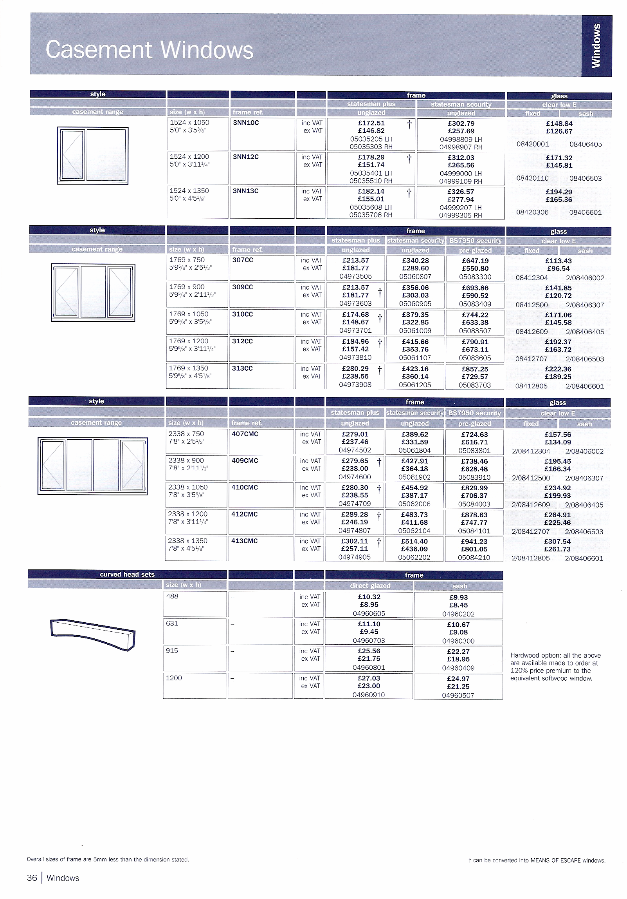

key skills

QUANTITY SURVEYING ASSIGNMENT

STUDENT’S NAME

KEY SKILLS COVERED  This assignment addresses the skills highlighted in bold type.  Circle those which have been achieved by the student. | LEVEL 1
 | C1.1.1 |  | N1.1.1 |  | ICT1.1.1
 | C1.1.2 |  | N1.1.2
 | C1.2.1 |  | N1.2.1 |  | ICT1.2.1
 | C1.2.2 |  | N1.2.2 |  | ICT1.2.2
 | C1.2.3
 | C1.3.1 |  | N1.3.1 |  | ICT1.3.1
 | C1.3.2 |  | N1.3.2
 | C1.3.3 |  | N1.3.3
 |  |  | N1.3.4
 | LEVEL 2
 | C2.1a.1 |  | N2.1.1 |  | ICT2.1.1
 | C2.1a.2 |  | N2.1.2
 | C2.1a.3 |  | N2.1.3
 | C2.1b.1
 | C2.1b.2
 | C2.1b.3
 | C2.2.1 |  | N2.2.1 |  | ICT2.2.1
 | C2.2.2 |  | N2.2.2 |  | ICT2.2.2
 | C2.2.3
 | C2.3.1 |  | N2.3.1 |  | ICT2.3.1
 | C2.3.2 |  | N2.3.2 |  | ICT2.3.2
 | C2.3.3 |  | N2.3.3
 | C2.3.4 |  | N2.3.4

COMMENTS

teacher’s notes

QUANTITY SURVEYING ASSIGNMENT

This assignment assumes that students are able to use a spreadsheet and insert formulae. Teachers will need to specify the type of bricks etc to be used.

A wider range of materials can be found at: http://www.trademate.co.uk/ .

To cover all Key Skills listed candidates will need to access the above website and find relevant information as set by the teacher to extend the search for materials. This can also be covered by including labour overheads.

To calculate the number of bricks per metre squared assume that a brick including bed is 225 mm long x 75 mm high. To calculate the number of tiles assume that you need 10 tiles per metre squared.
POSSIBLE VARIATIONS |  | Higher level students could do the following.  - Create their own headed paper with a logo to represent the company  - Add in labour costs  - Add in overheads  - The teacher can advise students on suitable rates for both of these.  - Provide alternative quotations that enable the client to see how a variation in the materials specification will affect the cost.

